**4. Jenkins & AWS**

**Objectives**

* Create a **jenkins** that will take a ***MySQL backup***
* Upload it through the internet
* Upload it to Amazon S3

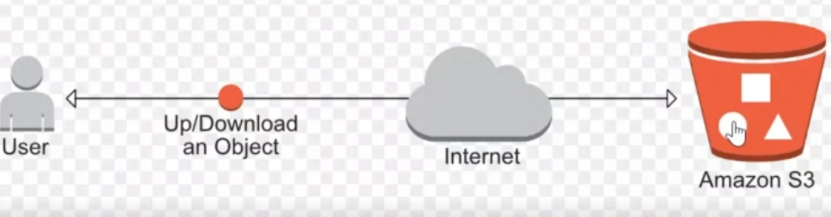

**Step 1 – Create a MySQL container on Docker**

* Update ***docker-compose.yml*** file and add a new image with a volume and password. (*see commands txt)*

**Step 2 - Install MySQL Client and AWS CLI**

* (*see commands txt)*

**Step 3 – Create a database**

* (*see commands txt)*